**The D’Arcys of Kiltullagh, Porridgetown East, and Magheramore**

*The D’Arcys of Kiltullagh were prominent in County Galway from the 16th through the 19th centuries and may be the ancestors of modern-day D’Arcy/Darcy families who trace their roots back to 19th century Porridgetown East and Magheramore. The following is an attempt to identify the nature of the family’s origins and sort out members of the two local groups.*

*-RF O’Connor*

**The D’Arcys of Kiltullagh**

The origins of various D’Arcy families who lived in and around the City of Galway in the 16th and 17th centuries have long been disputed. Their ancestors are often described as Anglo-Norman adventurers who came to England with William the Conqueror in 1066, moved to the west of Ireland, and there became one of the “Fourteen Tribes” of Galway. But since the 17th century, Irish historians have argued that at least the Kiltullagh branch descends from the ancient Gaelic ÓDorchaidhe clan, which had its roots about 70 miles north of Oughterard in Partry, near Lough Mask in County Mayo.

Dubhaltach MacFhirbhisigh (c.1590-1670) was a 17th century genealogist whose masterwork, the “Book of Genealogies,” profiles Gaelic and Anglo-Norman families from biblical times to the mid-1600s. He lived and worked in the City of Galway, where Patrick D’Arcy (1598-1668), a constitutional lawyer and member of the Kiltullagh branch, was said to have been among his many personal acquaintances.[1]

In addressing the issue of the ancient origins of the D’Arcys of Kiltullagh, 19th century Irish antiquarian John O’Donovan cited MacFhirbhisigh as follows:[2]

“MacFirbisigh’s genealogy ascribed a Gaelic origin to the Darcys of Galway and, as O Dorchaidhe (Anglicised as ‘O Dorsey’), were chieftains of an area about Partry in what would later be known as County Mayo. In his *‘Genealogies, Tribes and Customs of Hy-Fiachrach,’* MacFirbisigh recorded that the Darcy family who had by the sixteenth century come to prominence in the town of Galway was descended of these Gaelic O Dorceys.

“It was the view of the historian Martin J. Blake, writing in his *‘Blake Family Records 1600-1700,’* that Walter riabhach O Dorchaidhe, whom MacFirbisigh’s contemporaries gave as the first to establish the family in Galway, may have settled in the town of Galway sometime in the early-to-mid-fifteenth century. The family at some point dropped the ‘O’ in their surname and Blake noted that the original form of the family name in the old *Corporation Book* of Galwaywas ‘Dorsey’, which he remarked ‘would accurately represent the pronunciation of the Irish word Dorchaidhe.’

“One of the most prominent early members of this particular branch was James Riaveagh (sic) Dorsey, given by MacFirbisigh as ‘son of Nicholas, son of Conor, son of Patrick son of Thomas’ son of that same Walter riaveagh O Dorchaidhe. At an early stage, after settling at Galway, the family is believed to have become heirs to an established family of the town, the Develyns, and over time various members of the Dorseys or Darcys attained high office in the town.”

Given MacFhirbhisigh’s professional interests, and the fact, as reported, that he and Patrick D’Arcy were personally acquainted, it’s likely that at some point the question of the family’s origins would have come up in conversation. One might then believe that Patrick’s input would have strongly influenced the distinguished genealogist’s convictions on the subject.

If the O Dorchaidhe family of native Irish Catholics did abandon its rural origins and move down to the city in about 1450, as MacFirbisigh believed, they’d have encountered serious hostility.

The town of Galway was originally settled by Anglo-Norman families who erected both physical and social barriers to protect themselves from the locals, especially the belligerent O’Flahertys. To underscore their loathing of the native Irish, Protestant town fathers included the following sentiment in a 1518 by-law: “. . . neither O nor Mac shall strutte (sic) through the streets of Galway.”[3] To further that notion, in 1520 the King’s English was declared the language of the town and use of Irish in civil courts was banned.

Regardless of that ugly climate, the aggressive, savvy leader of the ÓDorchaidhe clan opted to turn his back on raiding neighboring clans and move to the biggest town in the region to seek his fortune. To ensure success, his strategy may have been to anglicized his name and adopt the way it was spelled locally, with an apostrophe and capital A, then use his brash self-confidence, perhaps sweetened by an engaging personality, to get accepted into Galway’s Tribal circles. Once his foot was in the door, the next move would be to marry into money.

The chart below traces the family’s line of inheritance over the three hundred years of its prominence.

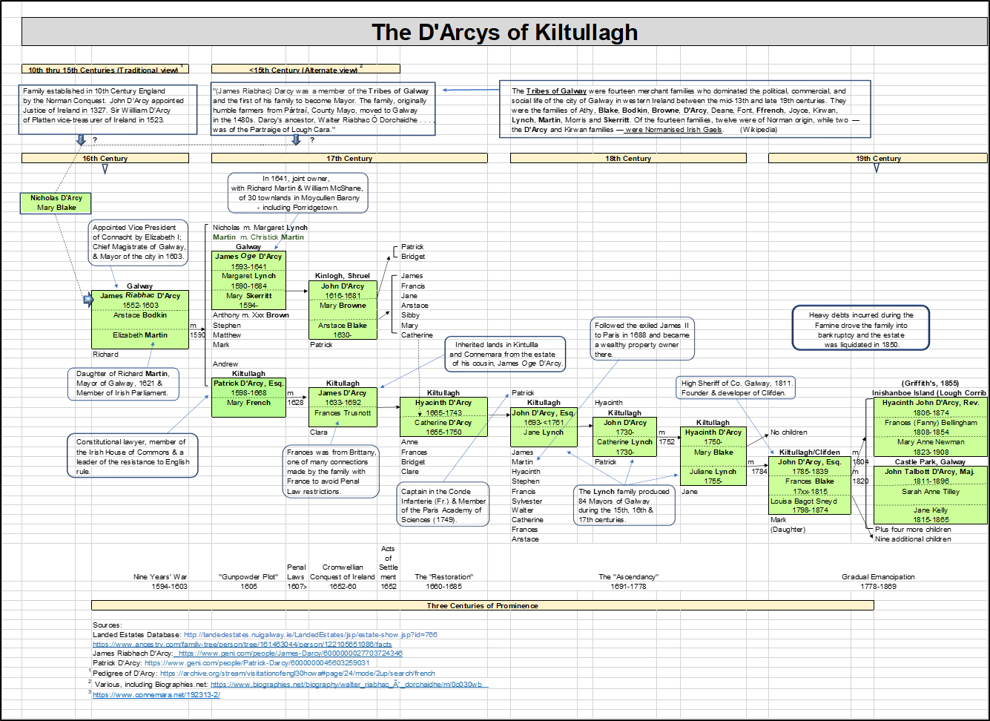It clearly illustrates how, after getting its start during the late 16th century, the clan systematically intermarried with influential Galway families, including the “Fourteen Tribes”, produced lots of children, educated them well, and encouraged them to set their sights high. The strategy worked and the family not only survived the turbulent Cromwell era, but prospered.

A few of the family’s more distinguished members:

* First to appear in Galway records was James *Riabhac* (grey-haired) D’Arcy. He was appointed by Queen Elizabeth I of England (1533-1603) as Vice President of Connacht and served as Chief Magistrate of Galway and Mayor of the City.[4]
* His eldest son, James *Oge* (the younger) D’Arcy was active in real estate. In 1641, in partnership with Richard Martin and another man, he owned thirty townlands scattered across Moycullen Barony.[5] Their portfolio included Porridgetown (both East and West), but not Magheramore.
* *Riabhac’s* younger son, Patrick, was a highly regarded lawyer, a member of the Irish House of Commons, an outspoken Jacobite and a leader in resistance to English rule. Subsequentto the Insurrection of 1641 he drafted a constitution for the proposed Irish Catholic Confederacy. For his actions he was imprisoned, his lands confiscated, and he was exiled to an island off the coast of Connemara.[6]
* John D’Arcy, Esq., the last head of the family before its dissolution after the Famine, was briefly the High Sheriff of Galway and later founded the city of Clifden. He prepared the Tithe Applotment Survey for Killannin Parish in 1829, in company with a major local landowner, Robert Martin. Two centuries before, his relatives had owned Porridgetown, among their other holdings, in the Barony of Moycullen.

Some of the family’s descendants rose to power in Galway, others in France, where they sent their children to avoid the onerous restrictions of the Penal Laws and to receive proper educations.[7]

It’s unclear when the family received their grant of land in Kiltullagh, near Athenry in East Galway, but it was reportedly conveyed because of an act of kindness performed by a female family member in saving the lives of English soldiers during the Civil War.[8]

The D’Arcys appear to have been good landlords in Moycullen and elsewhere, but heavy debts incurred during the Famine (1845-52) drove the family into bankruptcy. The estate was gradually reduced in size, then totally dissolved by 1859.[9]

Whatever their origins or the source of their early fortune, it’s clear that this family regularly produced intelligent, ambitious, and socially gifted individuals. They appear to have bypassed tradition and by dint of their willpower and natural talents, drove their unique ‘tribe’ to become a vital force in Galway and Connacht political and commercial circles.

As the family grew some of its members, particularly those in line of inheritance, became socially prominent and members of the bar. But not every member of the family would have had either access to or interest in pursuing those opportunities. These would have turned instead to other pursuits, becoming merchants, farmers and herdsmen.

In that context, it’s not much of a stretch to conceive that some of the family members may have settled in Porridgetown early in the 17th century when James *Oge* Darcy first acquired the townland. From the chart, it’s clear that James *Oge’s* line would have continued to expand after the line of inheritance shifted to his cousin James in the mid-17th century. Those of James’s descendants not fortunate enough to be on the main line were also quite numerous. Some, beginning as early as the late 17th century, two generations after James *Oge* D’Arcy, might have elected to set down roots in Moycullen Barony. It’s notable, though, that in Griffith’s Survey of 1855, two centuries after the family owned more than two dozen townlands in the area, D’Arcy families were living in only Porridgetown East and Pollagh. When they reached a point where they needed more land to feed their growing families - possibly during the 18th or pre-Famine 19th century while the Irish population was still expanding - some younger members may have shifted over to Magheramore.

* * *

The numbering system in the family group charts that follow connects historical figures with their immediate descendants. The prefix DK stands for the D’Arcys of Kiltullagh; DP for the Darcys of Porridgetown, and DM for Darcys of Magheramore. Successive generations each add a decimal place. For example, in the chart below, DK 1.0, John D’Arcy, Esq., had six children from his first marriage. We’re interested here in only the two oldest, who are identified, in order of birth, as DK 1.1, Hyacinth John D’Arcy, and DK 1.2, Major John Talbott D’Arcy. The latter’s immediate heir was his son, John Lionel Talbott D’Arcy, DK 1.2.1.

For security reasons, and to protect the privacy of living descendants, no attempts have been made to detail the names of individuals over three generations removed from people listed in Griffith’s.



**The Darcy Families of Porridgetown East**

Commissioners with responsibility for conducting the Tithe Survey for Killannin (Civil) Parish, including Porridgetown, in 1828, were two members of the landed gentry: John D’Arcy, Esq. and Robert Martin. D’Arcy was a member of the D’Arcys of Kiltullagh, who had been prominent in County Galway since the 16th century. Educated at Eton and Trinity, he owned property in the Parish of Omey, Ballynahinch, was a member of the bar and active in Galway politics. After serving briefly as High Sheriff of Galway in 1811, he fell into disfavor and was removed. He then turned his focus toward the estates he owned in Connemara and developing the town of Clifden.

Robert Martin was a member of the Martin family which, in the 17th century, had been granted large estates in the west of Ireland seized from the O’Flahertys. As head of the Martins of Ross, he had large estates in Killannin Parish, was highly regarded in Galway political circles, and considered locally as a benevolent landlord. (Note: early members of the Martin (Ballynahinch) family are said to have lived in Birch Hall (Curraveha), which borders Porridgetown on its northern edge.[10])

The report they produced does not contain the names of occupiers and simply offers a summary of funds collectable under the law (45£).[11]

Griffith’s Survey of 1855 lists 17 occupiers in Porridgetown East, including four men named Darcy (spelled with no apostrophe): Martin, John, Roger and John Jun. (junior). Robert Martin was the property owner [Family names of their neighbors included: Welby (2), Halloran (2), Flanagan, Walsh (2), Devine, Connor (2), McDonagh, Moloney, and Davern.] [12] l

There were 172 acres of cultivatable property in the townland. Two men, Patrick Moloney and Michael Davern each farmed about 20 acres, with the remainder split among fifteen others, who held just under nine acres apiece. All had access to 64 acres of peat bog. Nine acres of land put them in the category of “small farmers.”[13] The soil quality value of their acreage varied; Martin, John and Roger worked land worth about 8 shillings, 5 pence (8s. 5d.), above average for the townland (6s. 5d.); John Jr.’s land was worth less, about 5s. 8d. At six to eight shillings per acre, though, the land in Porridgetown East was very poor quality, probably not unusual for the entire west of Ireland. (1st class land would be valued at 20-30 shillings per acre; 2nd class at 13-20; 3rd class below 13s.)[14]

Living on the edge of poverty was a continuing challenge for tenant farmers needing to feed their large families. From the post-Famine period into the 20th century, crop failures periodically caused hard times that lasted from one to three years, compounded by the actions of crooked land agents.

“The Martins incurred heavy debts and never really recovered from the effects of the Famine but managed to hold on to their estate. . . After the death of James Martin in 1872, the Martin family left Ross for Dublin and did not return until 1888. . .While they were absent, a new agent took charge of the estate. His policy led to bitterness, discontent and evictions of tenants. About 1875, all the tenants of the townland of Porridgetown, which belonged to the Martins, were evicted from their homes to the side of the road. They lived in little huts and charitable people gave them food and lodgings.”[15]

“James Jackson, a local landlord of Kilaguile, was an agent of Robert Martin, who was often absent from his estate, as he worked as a journalist in London and Dublin. Jackson, on his own evidence to a commission in 1880, charged 40-50 per cent over the government valuation for his rents. He would evict tenants who refused to accept his terms. He said that he had been denounced by the tenant’s priest, Fr. Coyne, for his harsh conduct towards his tenants since 1875.[16]

“Cancellation Books” kept by the Valuation Office and updated every few years provide a definitive record of who leased and owned property in Porridgetown East over the period 1858-1978. There is no mention there of a “John, Jr.” [17]

Three Darcys (again, no apostrophe): Martin, John and Roger were living in the townland in 1858 and paying taxes. Martin Darcy, along with four other occupiers (Thomas Welby, Roger Walsh, Myles Connor, and Jas. McDonagh, Jr.) each held a house, office and about ten acres of land; their landlord was Robert Martin. At the same time, Roger Darcy (DP 1.1) and John Darcy (DP 1.2) each had houses on sections of land they were renting (sub-leasing) from Martin Darcy, the actual leaseholder.

The clear suggestion here is that the latter three Darcys were related in some way. In support of that, civil records (which form the basis for the family profiles attached) indicate that both John and Roger had sons (possibly first-born, but we currently lack proof of that) named Martin.

Civil records later reveal that there were two additional Darcy families living in the townland; one headed by Connor Darcy (DP 2.1), the other by Michael Darcy (DP 2.2). Both had first-born sons named John. Their father, (assumed as being John DP 2.0 on the chart, might well be the “John” named in Griffith’s. If so, it’s possible that a clerk needing to differentiate between two Johns simply labelled the younger John (DP 1.2), Martin’s son, as “John, Jr.” Details of Roger, John, Connor, and Michael’s families are shown on their respective family sheets.

While no direct blood links have been documented between the D’Arcys of Kiltullagh and Darcy families in either Porridgetown or Magheramore, there are hints of possible ties. The key to resolving those ties may lie with Michael Darcy (DP 2.2) and his wife, Mary Lynch.

The given names of two of Michael and Mary’s sons, Nicholas and Isidore, were not from the traditional list favored by most Darcy families in either Porridgetown or Magheramore. Whether those were inadvertent choices or quiet tributes to the family’s ancestors isn’t clear, but put in historical context, they could reveal ages-old links between D’Arcys and Lynches and other members of the “Fourteen Tribes of Galway.” Three examples:

* James *Riabhac* D’Arcy, Mayor of Galway in 1602-03 was the son of Nicholas D’Arcy. *Riabhac* also had a son he named Nicholas (Mayor of Galway in 1614), who was married to a Margaret Lynch.
* John D’Arcy of Kiltullagh (b. 1730), married Catherine Lynch in 1752. Catherine was the daughter of Isidore Lynch of Drimcong, whose ancestors had been granted 2,700 acres in the Barony of Moycullen in 1679.[18]
* There were also several Isadore Blakes (another of the “Fourteen Tribes”), including one (1685-1763) born to John Blake and Mary Lynch.[19]

It may be purely by chance that Isidore Darcy (DP 2.2.6) became Master of the Oughterard Workhouse around the turn of the 20th century, and that John Darcy’s daughter Anna Honoria (DP 1.2.2) and her husband Mathias Clancy had preceded him as workhouse Master and Matron during the 1890s. But assuming it wasn’t just about earning a salary, their willingness to help the poor reflected the works of Major John Talbot D’Arcy (1811-96), son of the last head of the Kiltullagh branch who had founded Clifden. During the Famine, “. . . as well as doubtless giving aid in Clifden, (D’Arcy) had a workhouse especially built on his land at the Inagh valley end of Kylemore. . ..” [20] The mountain of debt occasioned by personal spending of this sort drove the family into bankruptcy just a few years after the end of the Famine.

Michael Darcy (DP 2.2) also plays a part in a minor mystery involving the Lee family in neighboring Pollagh. Roger Lee was a descendant of Redmond Lee who, in the 17th century, lived in Moyaskeragh, an old clachan in Pollagh. The Lees were a large family of ancient origin and quite prominent in the Galway community.

In about 1850, Roger Lee married a woman named Kate. Five years later, in 1855, Griffith’s lists a John Darcy residing in Pollagh, on land owned by Roger Lee. John left that holding around 1860 and was replaced by Michael Darcy, who stayed on for another five years. It’s possible that these two may have been John Darcy (DP 2.0) and his son, Michael (DP 2.2). If that’s the case, it’s likely that Roger Lee’s wife Kate was actually Kate Darcy, the sister of both John (DP 2.0), and Martin (DP 1.0). (Accordingly, she’s shown as DP 3.0? on the Porridgetown Heads of Families chart.)

The reason why John, and later his son, Michael took up the holding in Pollagh may have been to free a section of land back in Porridgetown for use by a younger family member. The move was an easy one because the landlord in Pollagh, Roger Lee, had become John’s brother-in-law.

Apart from an early 20th century younger-generation marriage or two, there are no deep family ties evident between the Darcys of Porridgetown and their counterparts in Magheramore.











**The D’Arcy/Darcy Families of Magheramore**

Magheramore is located in both the Civil and Catholic Parishes of Kilcummin. Its Parish Register offers a scattering of clues because the priests there began recording baptisms and marriages - perhaps surreptitiously - in 1809. [21]

The Tithe Applotment Survey of 1828 reports that Stephen, Michael, and Tom D’Arcy lived in a section of Magheramore referenced as “The Arthur French St. George Estates;” while James Darcy lived in another part of the townland. [22] This suggests the three were either brothers or close cousins, and James a more distant relative. (DM 2.0 Michael’s son James (DM 2.4) was too young to be listed in this 1829 survey.)

Nothing is known at present about what became of James Darcy (DM 4.0), but it’s possible that this could be the same person as DM 2.4, another son of Michael D’Arcy and Mary Haughigan. It’s also possible that he relocated to Moycullen, where both a James Darcy and Margaret Darcy are listed in Griffith’s.

Griffith’s Survey of 1855 lists fifteen occupiers in Magheramore, including six D’Arcys. [23] Property owner was a retired British military man of Scots descent, named John Doig. [Other family names in the neighborhood included Moloney, Faherty, Gavan, Rutledge, Welby, Gibbons, and Logan (3).] The townland held about 907 acres, about two-thirds of which was cultivated. Soil quality in Magheramore was also 3rd class, averaging 2s. 3d., probably higher in peat content and well below the quality in Porridgetown. Plot sizes varied from 5 to 13 acres; the D’Arcy holdings averaged about seven acres each, with a soil value of 1s. 5d.[24] Raising enough crops to feed their families was much tougher than closer to the lake in Porridgetown, so the families in Magheramore must have endured a more difficult way of life.

Three of the six D’Arcys in Magheramore are clearly identified by agnomen as the sons of Michael (DM 2.0); while Stephen was the son of Tom (DM 3.0). Whoever was Anthony Darcy’s father wasn’t recorded, but he’s arbitrarily shown here by dotted line as another of Tom’s sons because Anthony and Stephen’s birth dates are close enough to have been brothers.

That said, we really can’t be confident about any of these birth dates, so it’s entirely possible that the Michael D’Arcy (DM 1.1) at the top of Column 2 could be the same person as Michael D’Arcy (DM 2.0) in Column 1, particularly if the latter had married young and, following tradition, named his first son (assumed to be Stephen (DM 2.1)) after his own father (DM 1.0).

Information about John Darcy (DM 5.1), son of Michael Darcy and Winny Sullivan,[25] is contradictory and incomplete. It’s possible that John was born in Magheramore but moved to Moycullen around 1860 after he married. He may have remained in that area and his descendants may have intermarried with Darcys from Porridgetown.

As mentioned earlier, apart from an early 20th century younger-generation marriage or two, and with the possible exception of John’s descendants in the paragraph above, there are no deep family ties evident between the D’Arcys of Magheramore and their counterparts in Porridgetown.

*Note: Ellen D’Arcy, DM 2.5, the daughter of Michael D’Arcy, DM 2.0, is the author’s paternal great-great-grandmother.*

















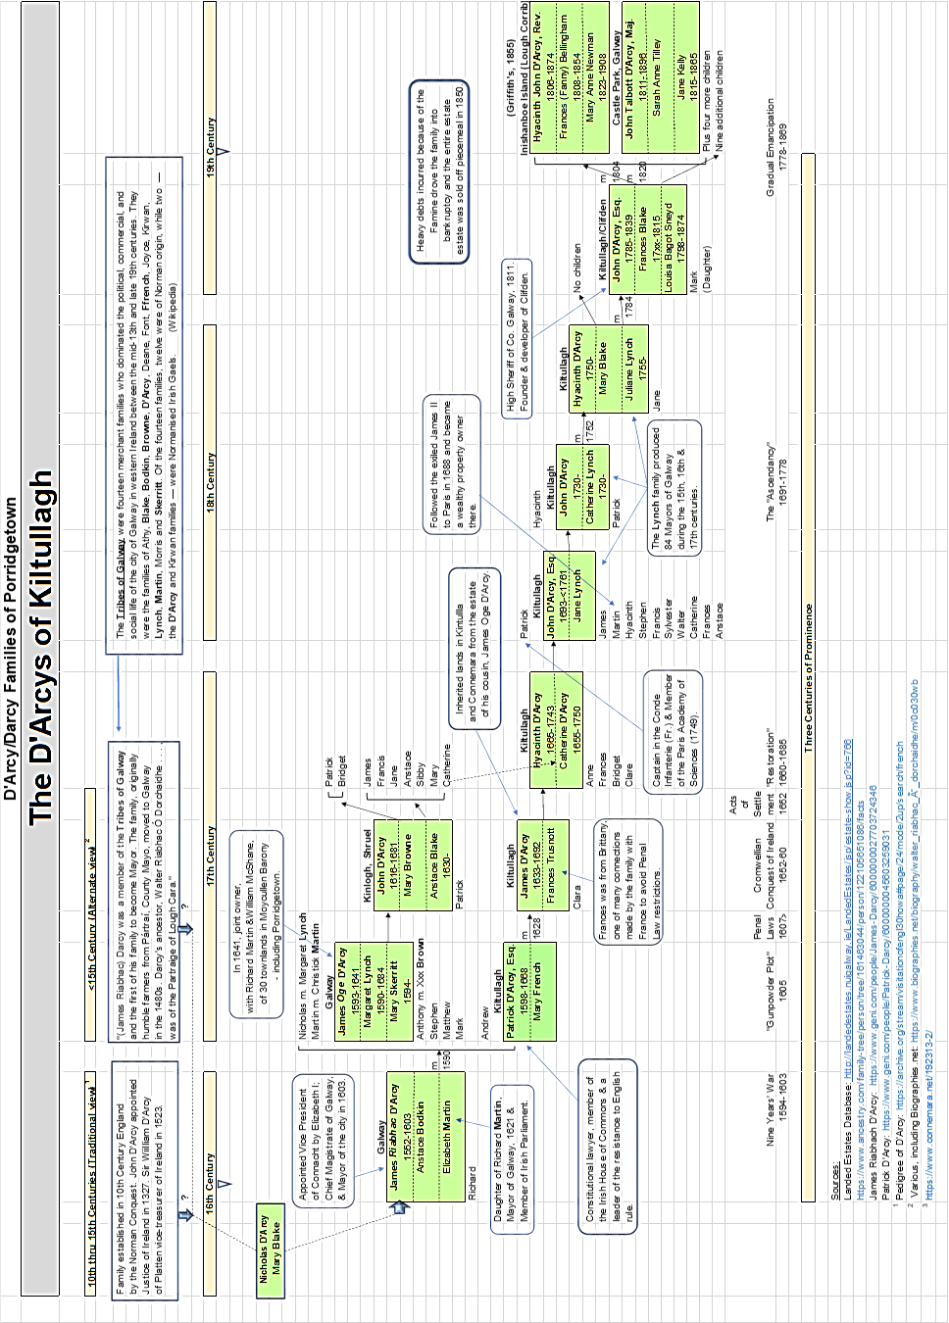

1. <https://en.wikipedia.org/wiki/Dubhaltach_Mac_Fhirbhisigh#Leabhar_na_nGenealach>
2. <http://burkeseastgalway.com/darcy-of-kiltullagh-etc/>
3. Hell or Connaught! The Cromwellian Colonisation of Ireland 1652-1660, Peter Berresford Ellis, first published in

   1975, Hamish Hamilton, Ltd., Belfast, Northern Ireland, pg.74.
4. <https://www.connemara.net/192313-2/>
5. <http://downsurvey.tcd.ie/landowners.php#l1=Darcy,+James+Oge&mc=53.321842,-9.28814&z=11>
6. <https://en.wikipedia.org/wiki/Patrick_D%27Arcy>
7. <http://www-history.mcs.st-and.ac.uk/Biographies/DArcy.html>
8. <https://www.connemara.net/192313-2/>
9. <http://landedestates.nuigalway.ie/LandedEstates/jsp/estate-show.jsp?id=766>
10. <http://www.landedestates.ie/LandedEstates/jsp/family-show.jsp?id=707>
11. <http://titheapplotmentbooks.nationalarchives.ie/reels/tab/004625670/004625670to00174.pdf> (Equivalent to

    about £4,000, or USD $5,000 today.)
12. <http://www.askaboutireland.ie/griffith-valuation/>
13. “Is There More in Griffith’s Valuation Thank Just Names, by James R. Reilly <https://irelandxo.com/sites/default/files/Griffiths%20background%20article.pdf>
14. The meaning of Value in Griffith’s Valuations, by 1857 Schnelle, [www.tiara.ie/TIARANewsletter/TIARANewsletterJune2019.pdf](http://www.tiara.ie/TIARANewsletter/TIARANewsletterJune2019.pdf) , and <http://www.askaboutireland.ie/enfo/irelands-environment/biodiversity/definitions/soils-in-ireland/> Contrast Porridgetown’s land values against the village of Kildare, in an area that supplied produce for the tables of Dublin. Farmland there was valued at 23s 5d.
15. “Local Landlords,” by Murt Molloy, published in Oughterard Heritage: <https://www.oughterardheritage.org/content/topics/murt-molloy-killannin-and-oughterard-local-history/local-landlords>
16. “Oughterard and Killannin, the Land League” by Murt Molloy, published in Oughterard Heritage: <https://www.oughterardheritage.org/content/topics/murt-molloy-killannin-and-oughterard-local-history/oughterard-and-kilannin-the-land-league-1879-82>
17. Images of Cancellation Books provided online by the Valuation Office, May 2019. There is a short gap between Griffith’s, recorded in 1855 and finalized in 1857, and the beginning of written tax records for the townland in 1858.
18. Pedigree of D’Arcy: <https://archive.org/stream/visitationofengl30howa#page/24/mode/2up/search/french>, and

    Lynch, Drimcong Estate: <http://landedestates.nuigalway.ie/LandedEstates/jsp/estate-show.jsp?id=864>
19. <https://www.myheritage.com/names/isidore_blake>
20. The Story of Connemara, Patricia Kilroy, Gill & McMillan, Ltd., Dublin, 1989.
21. Online at: <https://registers.nli.ie/parishes/0627>
22. Online at: <http://titheapplotmentbooks.nationalarchives.ie/search/tab/>
23. Online at: <http://www.askaboutireland.ie/griffith-valuation/>
24. The meaning of Value in Griffith’s Valuations, by John Schnelle, [www.tiara.ie/TIARANewsletter/TIARANewsletterJune2019.pdf](http://www.tiara.ie/TIARANewsletter/TIARANewsletterJune2019.pdf), and <http://www.askaboutireland.ie/enfo/irelands-environment/biodiversity/definitions/soils-in-ireland/>
25. Oughterard Parish Register, online at: <https://registers.nli.ie/parishes/0627>